(Approx. 4469 words)

Six Ways to Disorganize Your Music on Android Smart Phones
Part 1 of a 2-article series
By John Krout, Member, Potomac Area Technology and Computer Society, VA
March 2019 issue, PATACS Post
www.patacs.org
editor (at) patacs.org

When I bought my new Samsung Galaxy S7 smart phone in 2017, I found out by experiment that Google Play Music (GPM) is able to play not only MP3 song files but also FLAC song files.

FLAC is an acronym for Free Lossless Audio Codec. The first word is Free, meaning anyone can use it without paying a fee to the developers. The next word is Lossless. Unlike MP3, song files created by the FLAC code do not discard any digital bit of the audio CD music file. I prefer FLAC rather than MP3 because I sometimes hear odd little noises in MP3 song files, noises introduced by the lossy compression method used in MP3. Lossy means that some of the bits are not recorded faithfully, because the MP3 recording process discards some bits. The philosophy behind MP3 is that the bits deleted are not audible; perhaps human hearing varies a bit more than MP3 developers believes. Or perhaps the MP3 codec is not implemented perfectly by its developers.
The word CODEC is a contraction of coder and decoder. In this case, the ability to write a music file in a particular way (such as WAV or FLAC or MP3) is called coding, and the ability to read and play a song file recorded in a particular way is called decoding.
The tradeoff to use FLAC instead of MP3 is not trivial: a FLAC song file is typically at least three times larger than the corresponding MP3 file for the same song. I bought a 64 GB microSD card for my Galaxy S7 phone, and right now I have more than 1,500 FLAC song files on the card, occupying about 51 GB. Recently I replaced that 64 GB card with a 128 GB card, because my collections of songs and photos continue to grow.
After I installed FLAC songs on the smart phone microSD card, I noticed that, when the GPM app plays music, it does not always list the artist name for the song, instead it says Unknown Artist. I looked into the cause.

Ultimately, I found other symptoms and other problems. Most of the causes were my mistakes.

Read this article so you can learn to avoid my mistakes. And how to recognize and fix your own mistakes.

The info and methods outlined in these articles also apply to MP3 song files on Android phones.

METADATA
First of all, let me introduce the idea of metadata, and how it works in song files and the GPM app.

Metadata is descriptive data that is included in a file. If you shoot digital photos, you may already know that your phone or camera embeds the date and time of the photo, and the sensitivity (misnamed ISO), the aperture and the shutter speed in the JPEG photo file. In some photos, the map coordinates of the location are embedded, through use of a Global Positioning System receiver chip (GPS) included in all cell phones and some cameras.

Each of those descriptive tidbits embedded in a photo file is an example of metadata.

ID3 TAGS FOR SONG FILES
What kind of metadata might be useful in a song file? Artist name, Song title, Album name, album track number and many others can be included. The specific form of metadata used by the GPM app is called ID3 tags. It turns out that GPM can display and use that ID3 tag info it finds in a song file.

This is important: the GMP app gets rather confused if ID3 tags are not included in a song file.

When I found out that the GPM app reads and uses ID3 tags, I looked for a free Windows app to edit ID3 tags, since I use a Windows computer to read audio CD song files and write FLAC song files onto a hard drive. I found a good one, called AudioShell, and it works for both MP3 and FLAC files.

When installed, AudioShell is included in the rick click menu of Windows. An example is shown in Illustration 1. I selected the song file Taking Care of Business. Then the right click produced a popup menu including AudioShell. I selected that menu item and the submenu appeared, including Tag Editor.
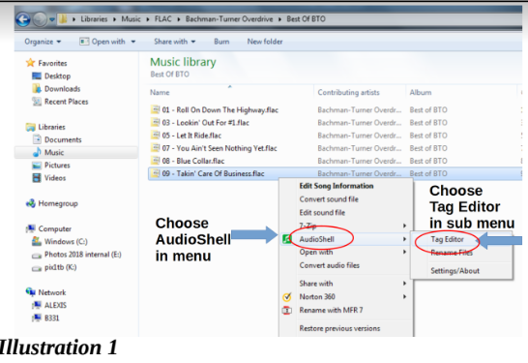
Selecting Tag Editor closes the menus and causes the Tag Editor window to open, as shown in Illustration 2. If no ID3 tags are included in the song file, then the fields for track number, artist, song title etc. will be blank. If ID3 tags are included, then the fields contain the current ID3 tag values, as shown in the illustration. To save the updated ID3 tag values, tap the bottom button labeled Save. That closes the window.
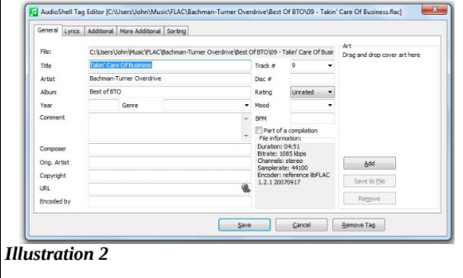

It is possible to select multiple song files and edit all their ID3 tags. If you do that, then the Tag Editor window includes an additional bottom button labeled Save and Next. Tapping that button saves the updated ID3 tag values and opens the next file's ID3 tag info, without closing and reopening the Tag Editor window. That is a very convenient feature when adding tags to several songs from say a single audio CD.

It took a couple of months of my spare time to create the FLAC files and add the ID3 tags. All this was done while the phone had the Android 7 operating system (OS) installed. I copied the FLAC song files onto the phone. As far as I could tell, when playing the songs on the phone, the GPM app used all of them. I did not literally check each and every song file using the GPM app.

THE GPM APP AND ITS VIEWS OF SONG FILES
The GPM app provides three different list views of song files:
- An alphabetic list of all song titles
- An alphabetic list of all albums, and within each album a list of all song titles on the album including the track number for each
- An alphabetic list of all artists, and within each artist a list of all albums by that artist, and within each album a list of all song titles on the album including the track number for each

While playing a song, the GPM app displays the song title and the artist name.
For the GPM app and its lists and displays, the significant ID3 tag items are: Song title, Artist name, Album name, and Album Track Number. Omit any of those, or misspell the text items, and grief happens.

SYMPTOMS, CAUSES AND REMEDIES
So, here are the mistakes I made, and how to recognize them using the GPM app, and how to fix them.

- Artist name is omitted: If the artist name ID3 tag is omitted, then the GPM app Artists list includes the album under the artist name Unknown Artist. That name appears at the bottom of the Artist list in the GPM app. I found about 15 albums under the name Unknown Artist. When playing such songs, instead of displaying the true artist name, the GPM app displays Unknown Artist below the song title. Unknown Artist for songs being played was the first symptom I noticed. The remedy is to enter the correct artist name in the appropriate ID3 tag for each song file.

Illustration 3 is a screen capture from my Android phone, showing the bottom of the alphabetic Artist list in the GMP app. You can see the final entry is Unknown Artist. At the time I captured this image, song of my songs lacked Artist name tags.
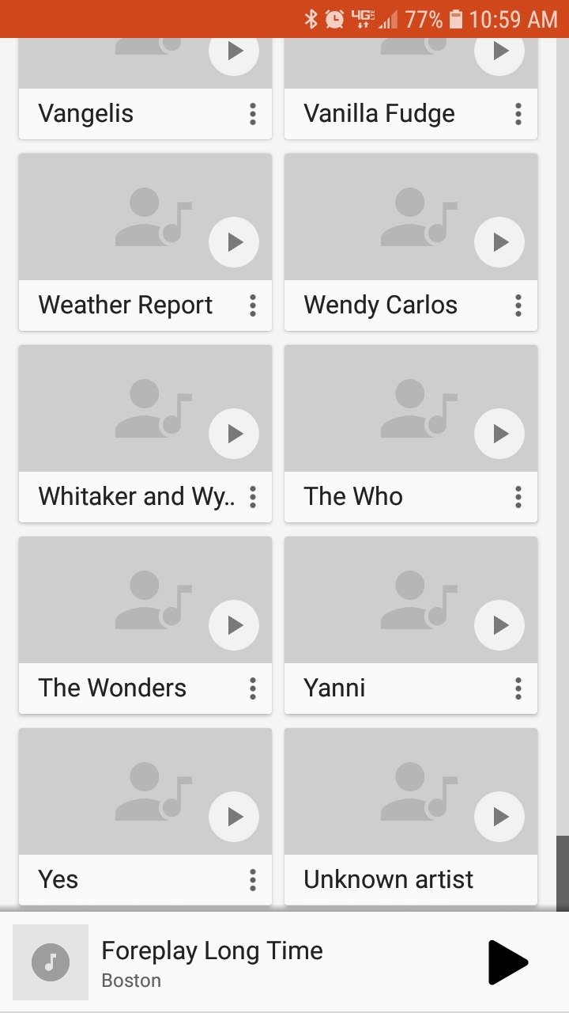
- Artist name is sometimes misspelled: When this happens in ID3 tags, the GPM app literally thinks that there are two different artists, not one. Examine the Artists list in the GMP app. The Artists list will include both names. The remedy is to correct the misspelling in the appropriate ID3 tag for each song file. For example, I had this problem with a German musician; I own four of his CDs, and I misspelled his name when creating ID3 tags for songs from three of the four albums.

- Song title omitted: When the song title ID3 tag is omitted, the GPM app will display the FLAC file name in the Songs list and when the song is played by the app. My ripper software included the track number at the beginning of the FLAC file name, so the GPM app displayed those file names at the very top of the Song Titles list. For instance, if I left out the Song Tile ID3 tag info for the song Come Together by the Beatles, then the GPM app would display 01-Come Together. The remedy is to type in the song tile in the appropriate ID3 tag.

- Track Number is omitted: When track number ID3 tags are omitted, if at least one song from al album has a track number among its ID3 tags, then the list of songs in the album will show that one song with its track number, and all others with no track number. If no songs from an album have a track number in their ID3 tags, then the album is not listed at all by the GPM app, although the GPM app will play the songs in shuffle Play mode. To make such an album visible, the remedy is to enter the correct track numbers in the appropriate ID3 tags for each song file.

This next one was quite surprising to me.

- Using the album name Greatest Hits for songs by multiple artists: If several artists have released the album entitled Greatest Hits, then the GPM app album list will include that album name once, and list all songs contained in every album name Greatest Hits under that one album title. This happened to me with the Monkees, Elton John, Journey, the Outlaws, Paul Revere and the Raiders, and a couple of other artists. According to the GPM app, the "album" contained over 35 songs by those artists.

The same thing could happen with the album name Best Of.

The remedy I used is to prepend the artist name to the phrase Greatest Hits in the ID3 tag for album title. So now I have songs contained in the Elton John Greatest Hits album name, the Monkees Greatest Hits album name, The Journey Greatest Hits album name, and so forth. The GPM app then properly identifies each artist with their own Greatest Hits album.

I made the fixes on the versions stored on my Windows computer hard drive, again using AudioShell, and then copied the updated song files onto the phone. I think having copies with corrected ID3 tags on the hard drive is a very useful backup approach in case my phone is lost, broken, or the microSD card is somehow erased or ruined.
By the way, AudioShell also has a convenient method of applying the Artist name and Album name to all song files from an album in a single action called Multi-Files, so a user does not need to modify ID3 tags for each song file one by one. It was fairly easy to correct the German name I misspelled. To make the corrections in over a dozen song files from those three albums, I had to use AudioShell Multi-Files only three times.
It is also possible to find smart phone apps that will let you edit ID3 tags of individual MP3 and FLAC song files, or small groups of files. One disadvantage of using a smart phone app to edit ID3 tags in song files is that you do not automatically keep track of ID3 tag updates and copy the updated song files to your computer.

A GLITCH INTRODUCED BY ANDROID 8
This next "mistake" resulted from a change made in the Android 8 operating system. In Android 7, this was not a problem.

6. Track number contains a leading zero character: It happens that AudioShell Tag Editor provides two different ways to enter a track number.
The first method allows the user to key in the track number: in the AudioShell window, click on the track number field and then use the numeric keys on the computer keyboard. See the accompanying screen capture image showing the AudioShell data entry window.

The second method provided by AudioShell Tag Editor, which I used for roughly the first 10% of my FLAC song file collection, is a pulldown menu, in which the values 1 through 9 are listed with leading zeros 01, 02, 03 etc.), no doubt to make the various values appear in numeric order in the menu. If you choose a value from 1 to 9 from the pulldown menu, then the leading zero is copied into the data entry field, and ultimately into the ID3 tag for Track number.

Leading zeros in track number ID 3 info caused no issue in the Android 7 operating system: the track numbers were recognized and displayed.

However, in the Android 8 operating system, the leading zero in the ID3 track number value causes the GMP app to treat the song just like the song had no ID3 tag track number value. See above for the symptom associated with a missing track number value. The remedy is to remove the leading zero.

While I discovered the symptoms and worked out the causes and remedies, I learned some other things. Behind the scenes on my Android smart phone, the Android operating system maintains indexes of ID3 tag information for song files: Album titles, Artist names, Track Number and Song titles. With a song file collection as large as mine, now more than 1,500 songs, each update to ID3 tags in a FLAC song file causes the Android OS to update the indexes, and it takes measurable time to do that. For instance, every time I added Artist ID3 tag values to songs in an album under the Unknown Artist name, I could see the GMP app take a second or two, blink, and remove the album from the album list group under the Unknown Artist name.

DIRECTORY STRUCTURE I CREATED FOR SONG FILES
One thing I want to make clear up front for the topic of directory structure: there is no one objectively correct or best way to organize it.

Here is what I chose to create on my microSD card in my Android smart phone and on my Windows computer. At the top level is the Music directory, which is apparently a mandatory directory in the sense that the Android operating system expects song files such as MP3 and FLAC to be found somewhere in the tree of directories under Music.
A little tip: the Android OS also treats any .AAC or .WAV files in the Recordings directory as song files. This is a bit vexing to me because I record various voice memos, and the recordings are in that directory. I certainly do not need to hear my own voice memos when I am using my smart phone to play music. So I remove those files to my Windows computer fairly often.

You could conceivably put all of your MP3 and FLAC song files in the Music directory. In my case that would be roughly 1,600 files. I thought that approach would make it very difficult for me to do some useful things: find and update one song file and confirm that an album of song files has been added (since the newly added files would be listed alphabetically, not grouped together). I don't think I have ever deleted any song files, but that too would be difficult.

So, to keep MP3 and FLAC song files separate, under Music I created a FLAC directory. If I still had a significant number of MP3 files on the phone, I would also create an MP3 directory. At this point I think I am down to about fifteen MP3 files, not a significant number.

Inside the FLAC directory, I created a directory for each Artist, such as Beach Boys, Beatles, Eagles etc.

inside each Artist directory, I created one or more Album directories. Under Beatles, for instance, I created a directory for Abbey Road, another for Help, another for A Hard Days Night, and several others, since I own many Beatles CDs.

See Illustration 4 for a Windows Explorer list of the first few Artist and Album directories in my FLAC directory tree.

Inside each Album directory, I store FLAC song files from the album.
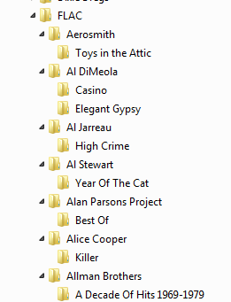

FINDING NEEDLES IN THE HAYSTACK, IN BULK
Since I did not know of any way to identify songs that contained a leading zero in the ID3 tag for track number, I looked into automatic ways to do that.

The first question is: what does an ID3 tag look like, inside a FLAC song file? To find out, I used a type of file viewer called a hex editor. This type of file viewer is especially valuable for viewing text embedded in a binary file such as a song file.
I downloaded a freebie application called wxHexEditor from the SourceForge web site. It runs on Windows and shows the contents of any file. It displays each and every character of a file as a two-digit hexadecimal (base 16) number. Additionally in a parallel column of the same window, it displays the alphabetic and numeric characters in the file in readable form. In that window, when looking at my FLAC song files, I saw that the track number ID3 tag takes the form of TRACKNUMBER=X, where X is one or two numerals.

You can see an example of the display by wxHexEditor in Illustration 5. Note that in the readable text on the right, the value TRACKNUMBER=01 appears for this song file (Big Shot by Billy Joel, from the 52nd Street album). This is an example of a TRACKNUMBER tag value that has a leading zero. I had to edit the ID3 tags for this song file to remove that leading zero.
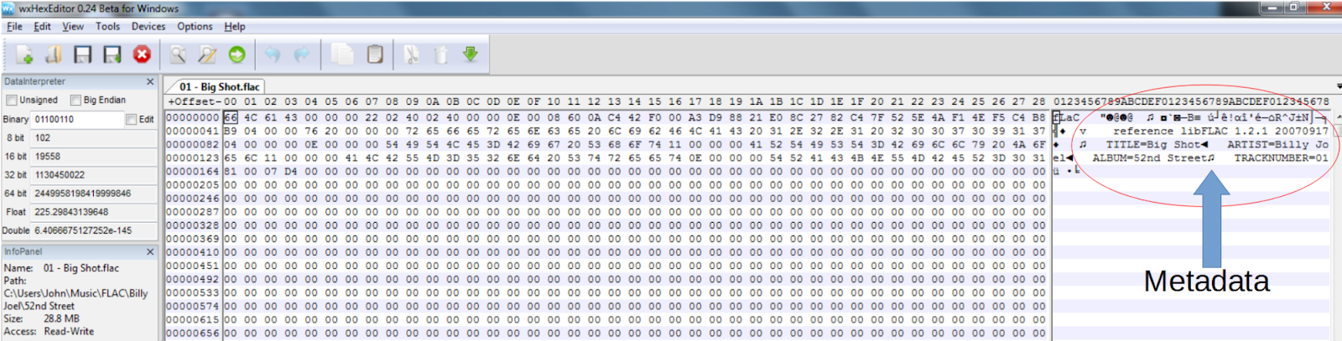

The word Editor means that you can also change the contents of a file using wxHexEditor. I did not use that capability. I just wanted to see the way that the metadata is identified and organized.

The second question is: How can I create a list of all FLAC song files that contain the text TRACKNUMBER=0? Such a song file list would be my checklist for ID3 tag updates. I found another free application called Swiss File Knife. This application has a truly amazing variety of features, but the one I wanted is similar to the Unix/Linux GREP command, which identifies all files containing a text pattern specified by the user, and all files not containing a text pattern specified by the user.

Alas, Swiss File Knife runs only in a DOS window. However, it can be made to create a file list, and that list can be directed into a Notepad text file. With some editing, that text file becomes a checklist for FLAC files to be modified.

The executable file I obtained was named sfk192.exe. I copied the executable file into a directory named C:\TOOLS on the Windows 7 computer I use for creating FLAC files. That directory name was suggested by the Swiss File Knife documentation, but you can use a different directory name or even a different disk if you wish.

Since skf192 runs in a DOS window, it is necessary to open a DOS window. To open a DOS window, I clicked on the Start Menu on my Windows 7 computer. At the bottom, in the search field, I typed CMD.exe and tapped the Enter key. That starts the DOS window.

On my Windows 10 computer, it happens that I installed a menu modification called Classic Shell, so that the Start Menu looks like the Windows 7 Start Menu. As modified, I can start CMD.exe in the same way on my Windows 10 computer. I have no idea how to start it on an unmodified Windows 10 computer.

In the new DOS window, I typed this command to add C:\TOOLS to the command path list, the group of directories known to contain executable files:
Set PATH=%PATH%;C:\TOOLS

That change enables me to execute skf192 no matter where I go in the directories on my hard drives.

Then I used the Change Directory (CD) command to move to the directory where I stored my tree of FLAC song file directories:
CD C:\Users\John\MusicFLAC

Then I typed the following Swiss File Knife command to find files containing the TRACKNUMBER=0 string:
sfk192 replace -pat /TRACKNUMBER=0/TRACKNUMBER=/ -dir . -file .flac

This command does not actually do text replacement. It lists the files that would be chosen for substitution. Here is an explanation of the various parts of the command line.

-pat specifies the text to be found (TRACKNUMBER=0) and the text to be substituted (TRACKNUMBER=). The gist is to remove the leading zero in the relevant ID3 tag.

-dir . specifies begin searching for files in the current directory. The symbol for the current directory is the period following the word dir.

-file .flac says look in all files with the extension .flac. This is not case sensitive.
Swiss File Knife searches all sub-directories automatically, which is ideal for the directory structure I use. Under the FLAC directory, as noted above, I have a directory for each artist (roughly 120 directories in my case). Under each artist, I have a directory for each album by that artist. In each album directory I put the FLAC song files for that album.

Swiss File Knife produced a very difficult output in the DOS window, overwriting each output line with the next. So, I killed it using the ancient DOS keystroke CTRL-C. Then I modified it to send all the output to a file:

sfk192 replace -pat /TRACKNUMBER=0/TRACKNUMBER=/ -dir . -file .flac > tracnknum_report.txt

Illustration 6 is a screen capture of the DOS window and the commands I typed as described above.
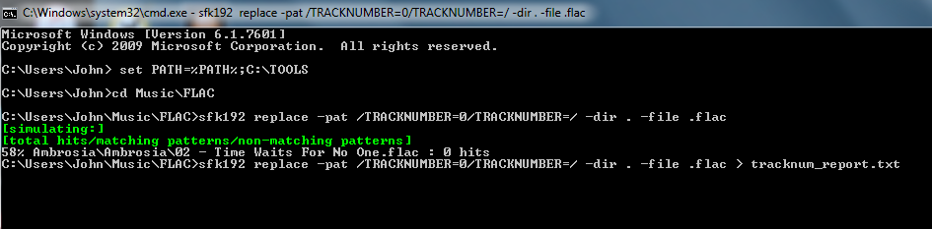

Because my FLAC song file collection includes 1,500+ files, it took Swiss File Knife quite some time to finish the report. And the file size was slightly more than 10 megabytes. That is not shocking in itself, since modern hard drives have terabytes of space.

I tried reading the report file with Notepad. It failed to recognize the end of each line in the file, so it displayed one gigantic string of text, very difficult to read. So I tried reading the report file using WordPad. It did recognize and display the end of each line of text, making for much easier reading.

Illustration 7 is a screen capture of WordPad showing the initial part of the report file.
It turns out that the fast way to identify each song file containing TRACKNUMBER=0 is to ask WordPad to search for the phrase “1 hits.” That is the phrase reported by Swiss File Knife when it finds TRACKNUMBER=0 in a song file's ID3 tags.
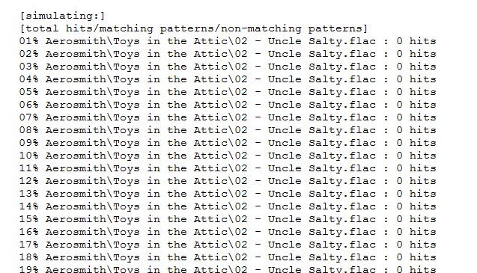

When I was finalizing this article in January 2019, I reran the report in order to create the screen captures I have included. I thought I had fixed all those TRACKNUMBER=0 values several months ago. However, I found another 20 songs that still included ID3 tags with TRACKNUMBER=0, so I fixed every one of those by removing the leading zero using AudioShell Tag Editor and copied the fixed files onto my Android phone.
In Part 2 of this article series, you will learn how you can use Swiss File Knife to detect the absence of ID3 tag info in your music files.

IS APPLE ALSO AFFECTED?
I have a corporate iPhone, but I do not put music on it. Here is my hypothesis: iPhones use ID3 tags, and iTunes sells music with ID3 tag embedded, or ensures that the ID3 tags are edited when you import an audio CD's songs.

From the days about six years back when I owned a personal iPhone, I still have iTunes installed and I have several hundred songs recorded in the M4A song file format used by iTunes and iPhones. Who knows, maybe someday I will again buy a personal iPhone.

So I found an M4A song file among that collection on my hard drive and used AudioShell Tag Editor to look at its ID3 tags. Sure enough, there are populated ID3 tags in the M4A files.

More interesting still, for track #4 from an audio CD, the ID3 tag read TRACKNUMBER=04/08. It turns out that 08 is the number of songs on the album, and 04 is the track number.

It is clear that iTunes and iPhone tolerate leading zeros, at least as of the iPhone 5, which was the last iPhone I owned.

CAN THE LEADING ZERO ISSUE IN ANDROID 8 BE FIXED?
I want to mention that, in July 2018, I sent email to both the publisher of AudioShell (Softpointer) and the publisher of the Android OS (Google, corporate name Alphabet) about the Android 8 leading zero problem.

The AudioShell app itself provided the email address for the publisher. I told Softpointer about the leading zero problem, and I said that the problem was not theirs, but I thought they could be part of the solution by eliminating the leading zero.

As you many know, Google is not the most transparent organization on this planet. It happens that I own a few shares of stock in Alphabet, the parent company of Google. I found the email address for Investor Relations Department on the corporate web site alphabet.xyz (I kid you not) and sent my description of the problem and its cause to that organization, including a mention that I am a shareholder. That tactic may sound familiar if you read my article series about influencing Internet Service Providers to continue Net Neutrality.

As of January 2019, I have yet to receive a response from either Softpointer or Google. I am not holding my breath, if you get my drift.
Software Products mentioned in this article:
AudioShell: https://www.softpointer.com/AudioShell.htm
wxHexEditor: https://sourceforge.net/projects/wxhexeditor/
Swiss File Knife: https://sourceforge.net/projects/swissfileknife/

About the author:
John Krout is a former president of WAC, one of the predecessor clubs that became PATACS. He hated English in high school and probably became an engineer in part to avoid writing, like so many engineers do. His former English teachers would probably be laughing hysterically in their graves if they learned that he is a writer and speaker on modern digital technology and its many uses since the 1980s. Admittedly, during his high school years, he did not have the advantage of word processors for easy revision, reorganization and spell checking. Also he writes now about what he knows, not about what the high school teachers told him to research.

